Final Project  
Jacob Batrano

CS-210 SNHU

## Overview

Designed to optimize Corner Grocer's store layout, this program analyzes and displays daily sales data. The key features allow users to view the frequency of items purchased both numerically and visually through a histogram.

## Design Highlights

### ItemTracker Class

This class serves as the core, encapsulating all functionalities:

* Constructor: Initializes the data from an input file and creates a backup (frequency.dat).
* getItemFrequency: Returns the frequency of a requested item.
* displayAllFrequencies: Lists items with their frequencies.
* displayHistogram: Shows a histogram with asterisks representing item frequencies.

### Data Management

C++ Maps are used to efficiently track items and their frequencies.

### User Interface

A straightforward menu ensures easy navigation. Users can:

* Find a specific item's frequency.
* View all item frequencies.
* See a histogram of the frequencies.
* Exit the program.

## Screenshots Guidance

* Main Menu: Capture the initial menu screen.  
  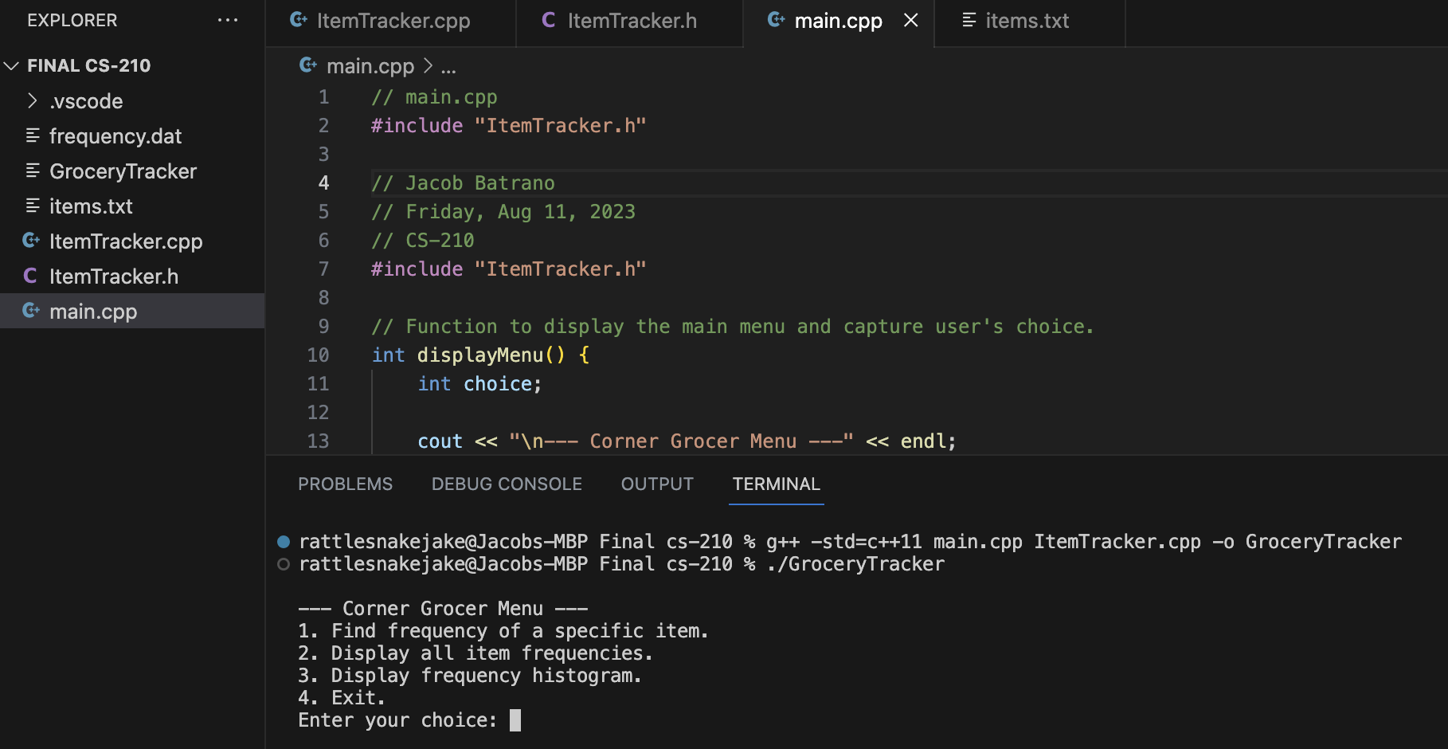
* Specific Item Frequency: After selecting the first option, screenshot the result for an item like "Yams".  
  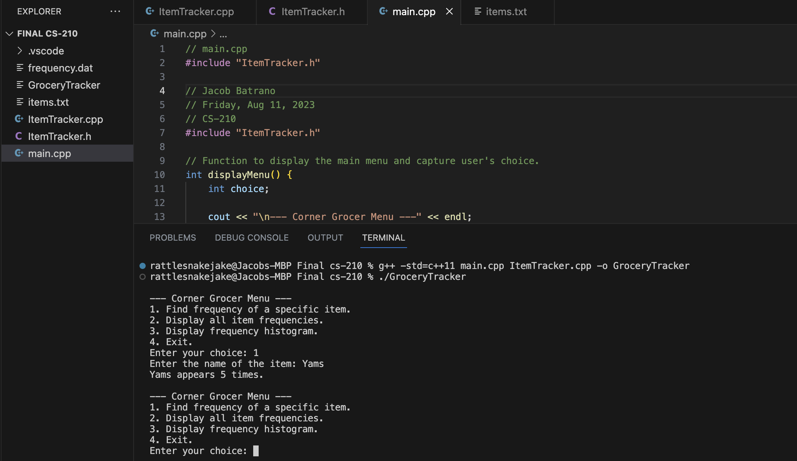
* All Frequencies: For the second option, screenshot the entire item-frequency list.

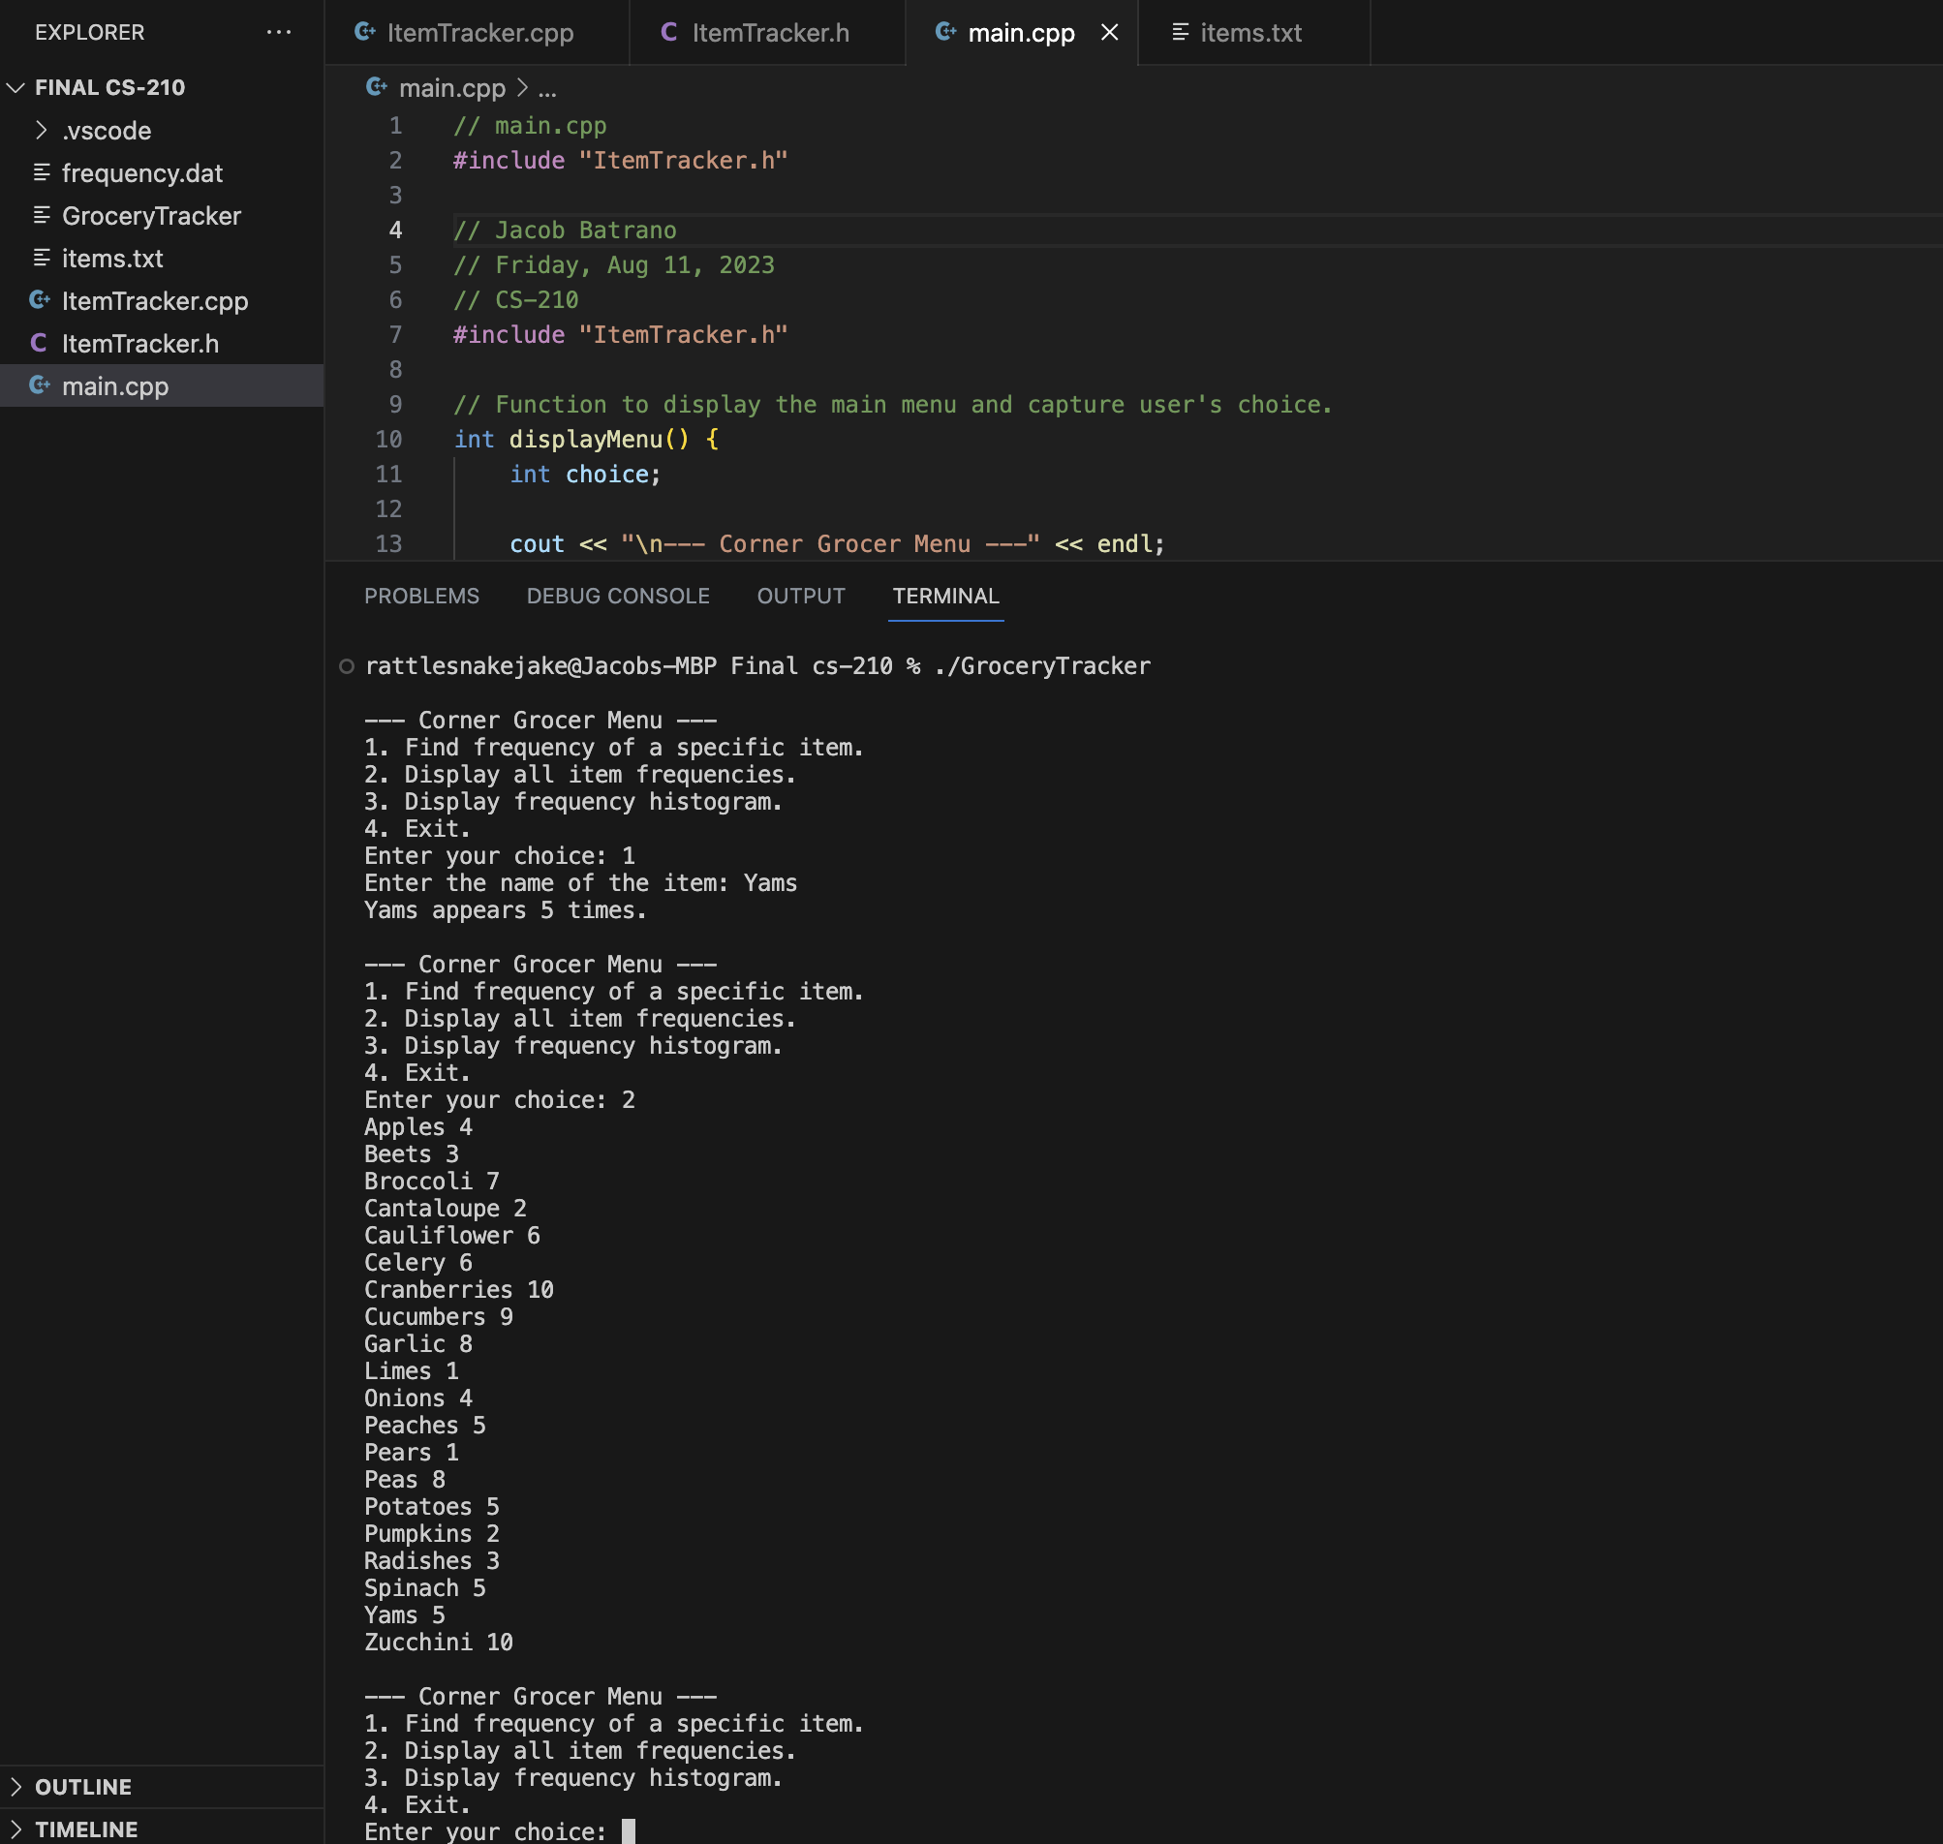

Histogram: Post selecting the third option, capture the displayed histogram.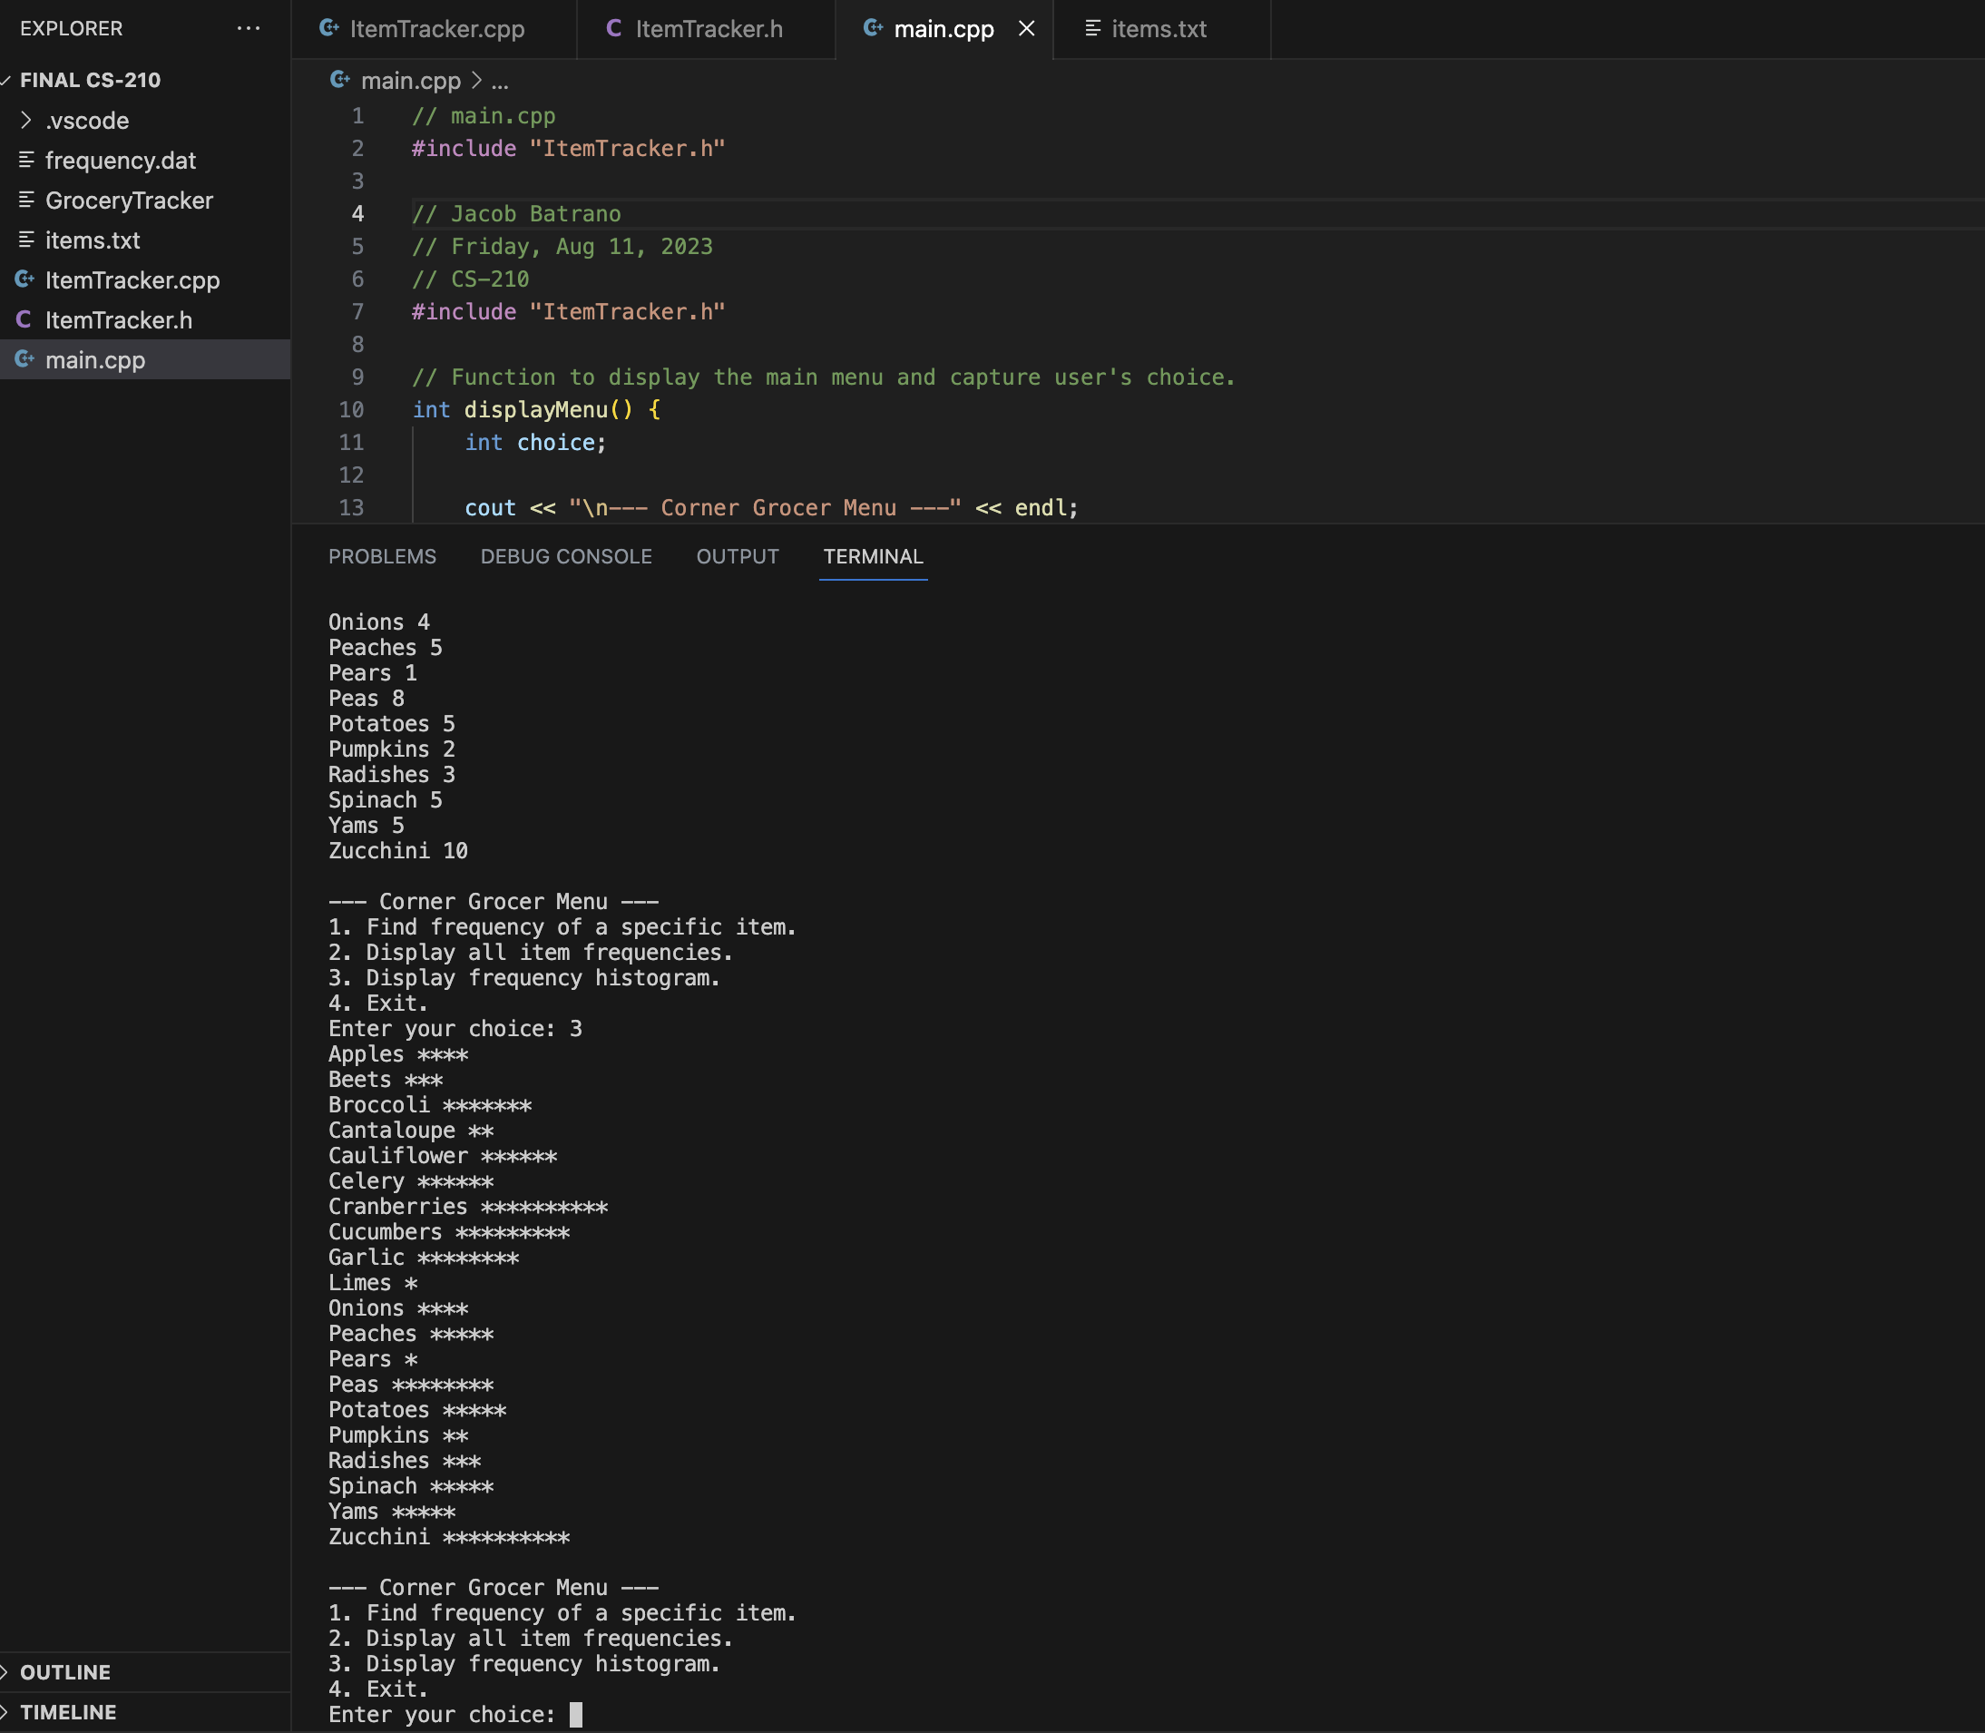

## Wrap-Up

Crafted in C++, this tool offers Corner Grocer insights into sales patterns, ensuring they can make informed decisions to enhance customer experiences.